Dear Seventh Grade Students and Families,

Welcome to seventh grade: The middle of Middle School! We hope you are looking forward to starting another year at HDMS! Below is a list of things that will make your year easier, more organized and more fun :) **Throughout the summer, please check in to “Class of 2029!” Google Classroom.  I will be posting Information and updates as needed.**

**The classroom code is abmidvz**

**Please note: The 7th grade students will not receive an agenda from the school this year. We are encouraging the use of online calendar/planner apps on Google.** Enjoy the rest of your summer and we all look forward to seeing you on **Monday, August 28th** for the start of the 2023-2024 school year!

**7th Grade Supply List**

**One of the following systems to keep track of paper handouts and notes:**

* **2-4 inch 3 ring binder with hole-punched folders (zipper optional)**
* **Accordion folder with at least 5 tabbed pockets**

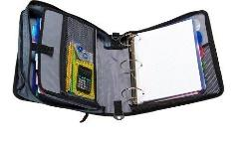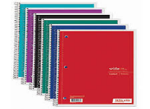

**Two Spiral Notebooks for Science**

**Utensil pouch that can be clipped into binder or carried to class with:**

* **Pencils (needed for math)**
* **Highlighters (Five colors needed for ELA)**
* **Erasers**
* **Colored pencils**
* **Chromebook cover (optional) for an Acer Chromebook 11.6" Traditional Laptop**
* **Planner/Agenda (optional, but if you prefer paper agendas please grab one)**
* **Earbud style headphones (for testing and interactive Chromebook activities)**
* Can’t wait to see you!
* The Seventh Grade Team
* **Mrs. Beaudreau  -   Ms. Montanez    ~    Mr. Chapin    ~    Mr. Lefko     ~     Mr. Young**